**PIZZA SALES SQL QUERIES**

1. **KPI’S -**

**1.Total revenue:**

select sum(total_price) as Total_Revenue from pizza_sales;

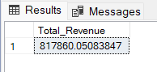

**2.Average order value:**

select sum(total_price) / count(distinct order_id) as average_order_value from pizza_sales

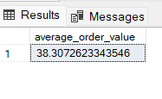

**3.Total Pizzas sold:**

select sum(quantity) as total_pizza_sold from pizza_sales;

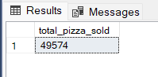

**4.Total Orders:**

select count(distinct order_id) as total_orders from pizza_sales;

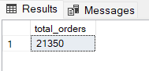

**5. Average pizzas per order:**

select cast(sum(quantity) as decimal(10,2)) /

cast( count(distinct order_id) as decimal(10,2)) as average_pizza_per_order from pizza_sales;

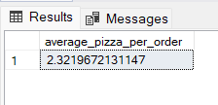

**5. Percentage of total sales:**

select pizza_category, (sum(total_price) *100) / (select sum(total_price) from pizza_sales) as pct_total_sales

from pizza_sales

GROUP BY pizza_category

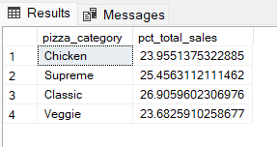

**Percentage of total sales by any particular month:-**

select pizza_category, (sum(total_price) *100) / (select sum(total_price) from pizza_sales) as pct_total_sales

from pizza_sales

where MONTH(order_date) = 1

GROUP BY pizza_category

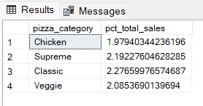

**Total sales with percentage of any particular month:-**

select pizza_category, sum(total_price) as total_sales,sum(total_price) *100 /

(select sum(total_price) from pizza_sales where MONTH(order_date) = 1) as pct_total_sales

from pizza_sales

where MONTH(order_date) = 1

GROUP BY pizza_category

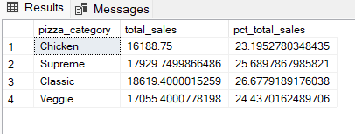

**Total sales with percentage of any particular month (By Size):-**

select pizza_size, cast(sum(total_price)as decimal (10,2)) as total_sales,cast(sum(total_price) *100 /

(select sum(total_price) from pizza_sales) as decimal(10,2)) as pct_total_sales

from pizza_sales

GROUP BY pizza_size

order by pct_total_sales desc

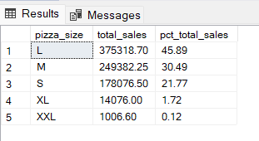

**Total sales by Pizza Name:-**

select pizza_name, cast(sum(total_price) as decimal(10,2)) as total_revenue from pizza_sales

group by pizza_name

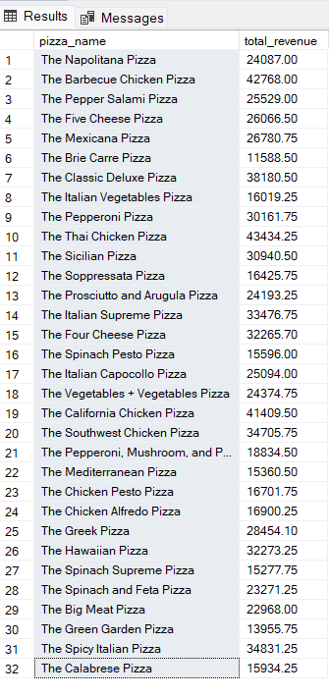

**6. Top 5 Pizzas By Revenue:-**

select top 5 pizza_name, cast(sum(total_price) as decimal(10,2)) as total_revenue from pizza_sales

group by pizza_name

order by total_revenue desc

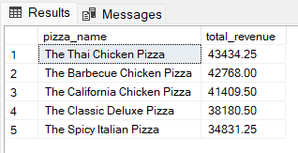

**7. Bottom 5 Pizzas By Revenue:-**

select top 5 pizza_name, cast(sum(total_price) as decimal(10,2)) as total_revenue from pizza_sales

group by pizza_name

order by total_revenue asc

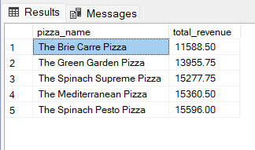

**8. Top 5 Pizzas By Quantity:-**

select top 5 pizza_name, sum(quantity) as total_quantity from pizza_sales

group by pizza_name

order by total_quantity desc

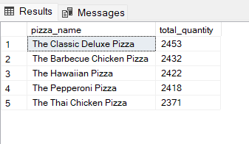

**9. Bottom 5 Pizzas By Quantity:-**

select top 5 pizza_name, sum(quantity) as total_quantity from pizza_sales

group by pizza_name

order by total_quantity asc

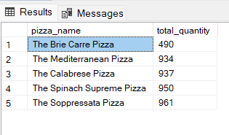

**10. Top 5 Pizzas By Order Id:-**

select top 5 pizza_name, count(distinct order_id) as total_orders from pizza_sales

group by pizza_name

order by total_orders desc

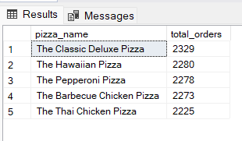

**11. Bottom 5 Pizzas By Order Id:-**

select top 5 pizza_name, count(distinct order_id) as total_orders from pizza_sales

group by pizza_name

order by total_orders asc

